**Lab 10:**

**Characterization of the MOSFET**

Name: Wan-Yu Liao

ECEN 325 Section 514

TA: Mandela

Lab Date: November 7, 2019

Lab Report Due Date: November 12, 2019

**Simulations**

**(1) NMOS using 2N7000G**

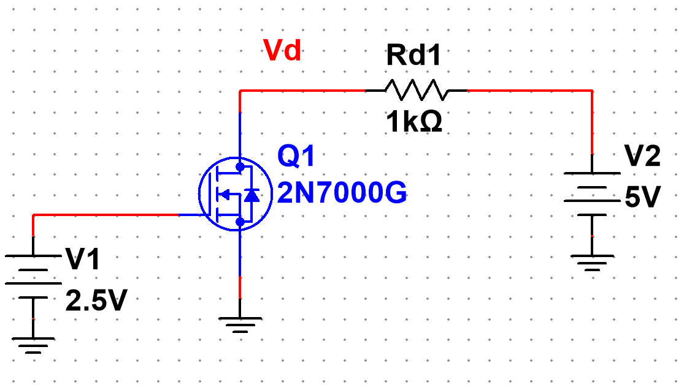

**Figure 1:** Schematic for NMOS using 2N7000G ▲

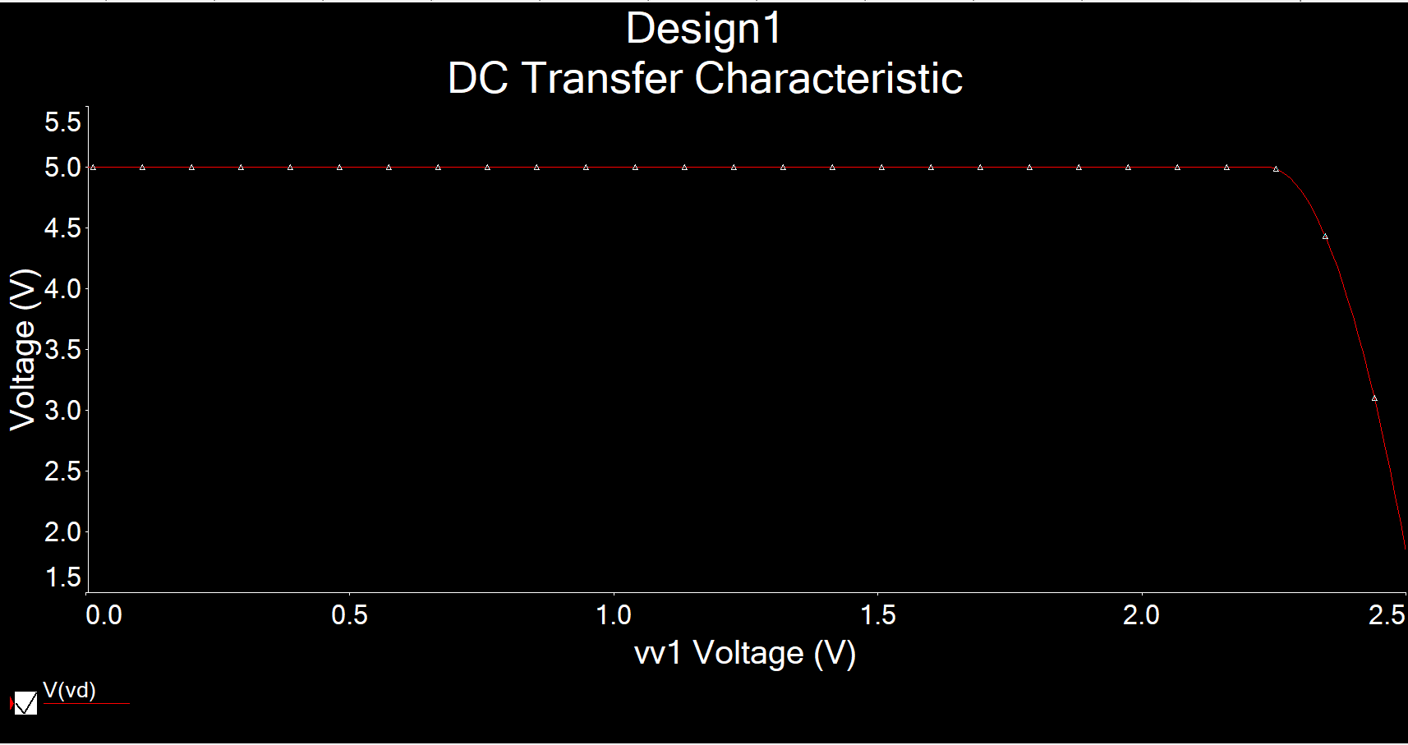

**Figure 2:** Simulation of NMOS characterization circuit using DC sweep of V1 from 0 to 2.5V,

while V2 = 5V ▲

**Figure 3:** Excel plot of NMOS characterization circuit using DC sweep of V1 from 0 to 2.5V,

while V2 = 5V, where Id = (5-Vd)/1000 ▲

**Figure 4:** Excel plot of NMOS characterization of derivative of Id’ vs. Vgs▲

Threshold Voltage Vt = **2.23V**

Transconductance parameter = (0.023218-0)/(2.5-2.23) = **0.086**

**(2) NMOS using CD4007N**

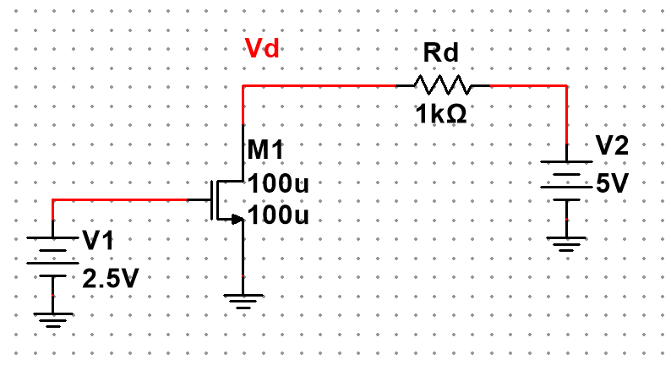

**Figure 5:** Schematic for NMOS using CD4007N (β=102mA/V2, VTN=2.0V) ▲

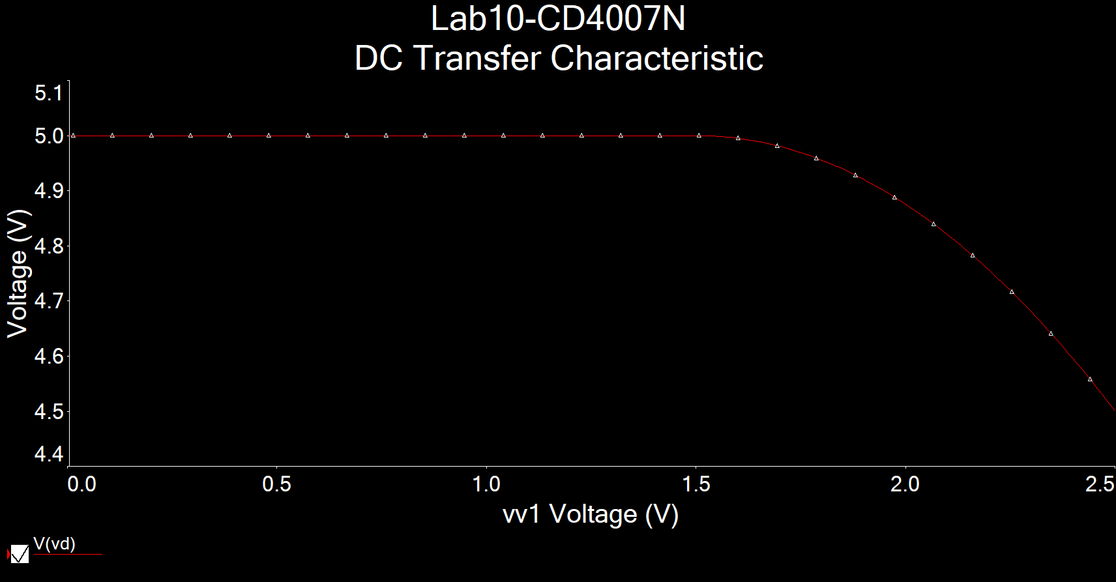

**Figure 6:** Simulation of NMOS characterization circuit using DC sweep of V1 from 0 to 2.5V,

while V2 = 5V ▲

**Figure 7:** Excel plot of NMOS characterization circuit using DC sweep of V1 from 0 to 2.5V,

while V2 = 5V, where Id = (5-Vd)/1000 ▲

**Figure 8-1:** Excel plot of NMOS characterization of derivative of Id’ vs. Vgs▲

**Figure 8-2:** Excel plot of NMOS characterization of derivative of Id’ vs. Vgs Decimated▲

Threshold Voltage Vt = **1.5V**

Transconductance parameter = **0.001A/V2**

(3) PMOS using CD4007P

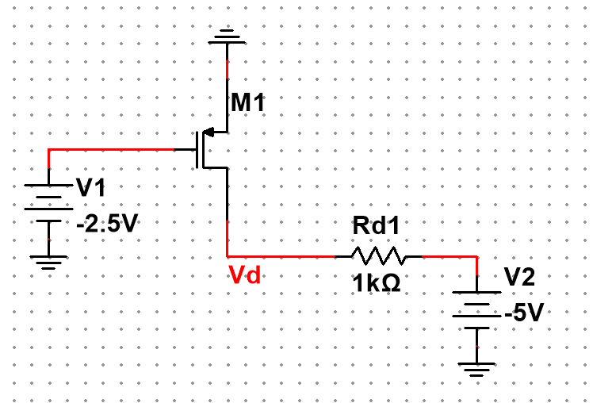

**Figure 9:** Schematic for PMOS using CD4007P (β=102mA/V2, VTN=2.0V) ▲

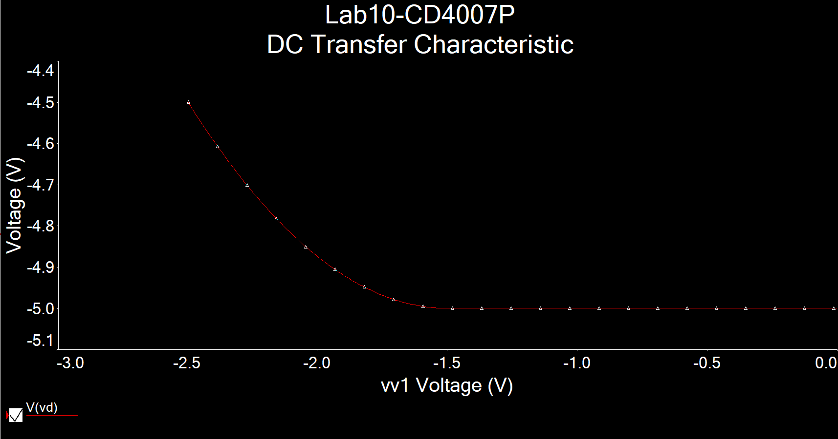

**Figure 10:** Simulation of PMOS characterization circuit using DC sweep of V1 from -2.5 to 0V,

while V2 = -5V ▲

**Figure 11:** Excel plot of PMOS characterization circuit using DC sweep of V1 from -2.5 to 0V,

while V2 = -5V, where Id = (Vd+5)/1000 ▲

**Figure 12-1:** Excel plot of PMOS characterization of derivative of Id’ vs. Vsg▲

**Figure 12-2:** Excel plot of PMOS characterization of derivative of Id’ vs. Vsg Decimated▲

Threshold Voltage Vt = **1.5V**

Transconductance parameter = **0.001A/V2**

**Measurements**

**(1) NMOS using 2N7000G**

**Figure 13:** Plot of ID vs. VGS ▲

**Figure 14:** Plot of decimated ID vs. decimated VGS ▲

**Figure 15:** Plot of decimated $\frac{dI_{D}}{dV_{GS}}$ vs. decimated VGS ▲

β = 0.023 A/V2, Vt = 1.84V

**(2) NMOS using CD4007N**

**Figure 16:** Plot of ID vs. VGS ▲

**Figure 17:** Plot of decimated ID vs. decimated VGS ▲

**Figure 18:** Plot of decimated $\frac{dI_{D}}{dV_{GS}}$ vs. decimated VGS ▲

β = 0.0012 A/V2, Vt = 1.4V

**(3) PMOS using CD4007P**

**Figure 19:** Plot of ID vs. VSG ▲

**Figure 20:** Plot of decimated ID vs. decimated VSG ▲

**Figure 21:** Plot of decimated $\frac{dI_{D}}{dV_{SG}}$ vs. decimated VSG ▲

β = 0.0018 A/V2, Vt = 1.5V

**Table**

|  |  |  |  |  |
| --- | --- | --- | --- | --- |
|  | Simulation | | Measurement | |
|  | β (A/V2) | Vt (V) | β (A/V2) | Vt (V) |
| 2N7000G | 0.086 | 2.23 | 0.023 | 1.84 |
| CD4007N | 0.001 | 1.5 | 0.0012 | 1.4 |
| CD4007P | 0.001 | 1.5 | 0.0018 | 1.5 |

**Comment**

In the prelab simulation, I used β = 0.001A/V2 and Vt = 1.5V. For both CD4007N and CD4007P, the simulation and measurement values are similar. For 2N7000G, the simulation value and measurement value are kind of different. This might due to the real-world component has others factors that affect the output values.